Day 3 answers

import turtle

myPen = turtle.Turtle()

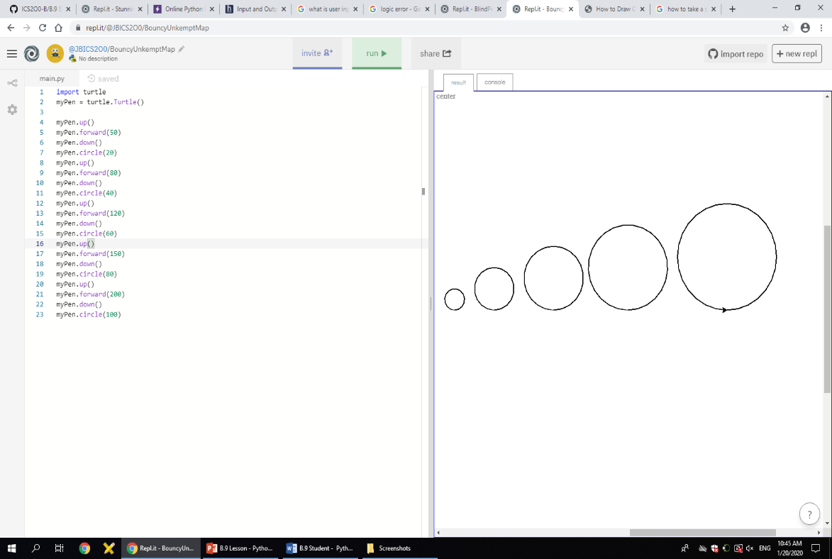myPen.up()

myPen.forward(50)

myPen.down()

myPen.circle(20)

myPen.up()

myPen.forward(80)

myPen.down()

myPen.circle(40)

myPen.up()

myPen.forward(120)

myPen.down()

myPen.circle(60)

myPen.up()

myPen.forward(150)

myPen.down()

myPen.circle(80)

myPen.up()

myPen.forward(200)

myPen.down()

myPen.circle(100)